First study in bilibili for the basic knowledge in 5_11.
Next there is the study notes:
What is MM-DOS?
The DOS_HEADER
The PE_HEADER
To load loadPE must konw how to use loadpe and how to use vs
//一个程序被编译成二进制，每一个区域块的二进制代码都有特定意义。一切皆是二进制！！！！从底层分析程序，解析程序能力很重要。
//每一个区段都有特定的名字，基础遍历解析区段语句操作
//数据结构目录以及计算偏移量，地址转换函数
//总结一下：今天学了MM-DOS,PE的HEADER以及解析方法，看了一下一些stuct的定义，还学了数据目录表以及解析还有一个函数，计算地址转换函数。

This time emmm...now is 5-13 12:20pm but i must finish this daily study_report
typedef struct _IMAGE_DOS_HEADER { // DOS .EXE header
WORD e_magic; // Magic number

QUESTION：for this example i know that the ‘e_magic’is a variable name but what does the ‘WORD’mean? What is the e_magic’s data type is?I know the e_magic takes up tow bytes in memory.//for example,i has studied basic data type such as ‘int’,’float’ and so on.but i don’t know what the ‘WORD’ is.
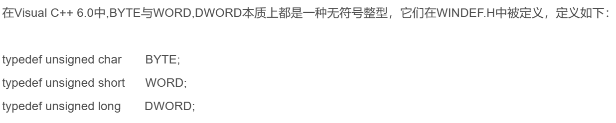
Why use that?
I need to know how to use vs to take project!!!!!it is important!!!and i need to analyse the code clearly!!!!!!!!!!!!
What is PE format!!//什么是区段表，数据目录，导入表
Result：it is beyond my ability,so i just studied the IMAGE_IMPORT_DESCRIPTOR.just a little.i just know a little about PE format!i need more!tomorrow.

导出表！！！只有动态链接库才有导出表exe文件没有
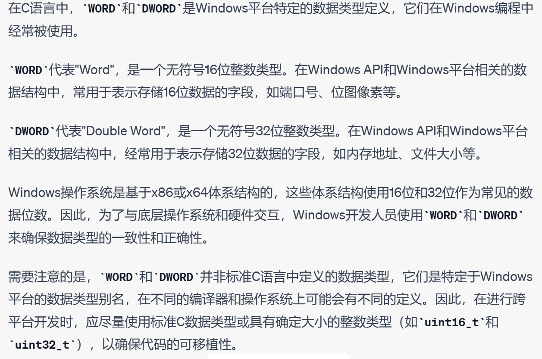
WORD和DWORD具有平台性，windows平台特定的数据类型，用来存16位和32位数据的字段。

Ok,today is 5_13 , i learned that what does RVA means!!it means “Relative Virtual Address” ,and in Chinese means “相对虚拟地址”!

I finish the ExportTable , and then i will do the code for RelocTable “重定位表解析”.
QUESTION: what is Virtual Address?这玩意到底是什么？什么叫虚拟地址？为什么要叫虚拟地址？它存的是什么？
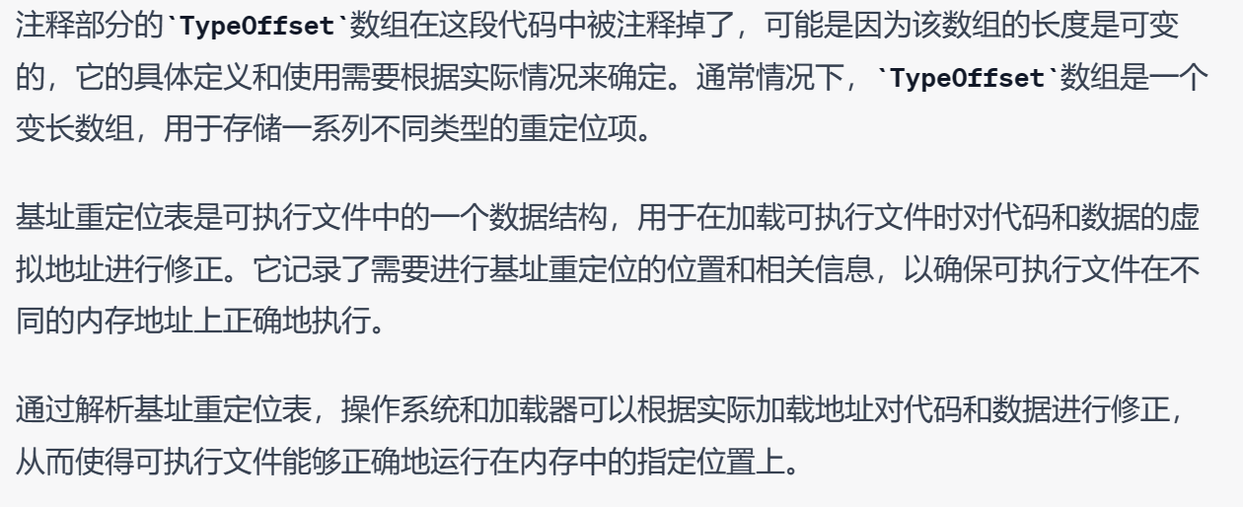
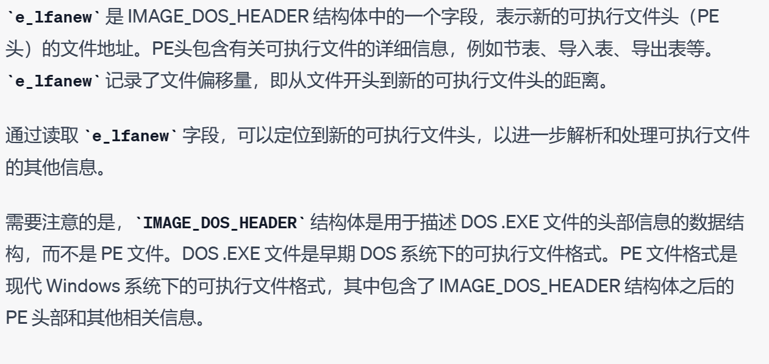

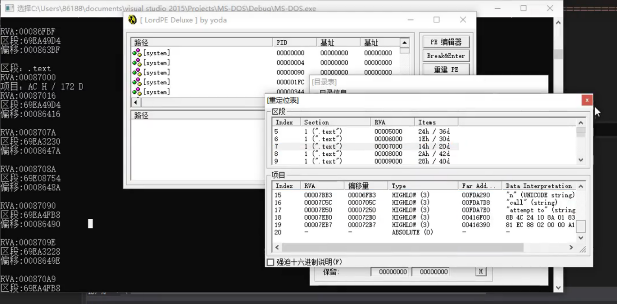
5_14
Analysis of TLS Data Structure Table and 延迟导出表
DLL ： Dynamic Link Library 动态链接库
I need to load 010Editor to analyse the binary code of exe file.
//下面是学习和写博客的步骤
//博客内容：1.下载loadPE 2.学习使用vs 3.学习PE结构基础以及PE结构解析
Step1 首先要看看这个重定位表定义的结构
Step2 然后把如何写解析函数给写出来
//到五月13号，PE结构解析还没学完，PE结构基础还没看，还没下载loadPE，还没熟悉使用VS（这个看看博客就行了）。
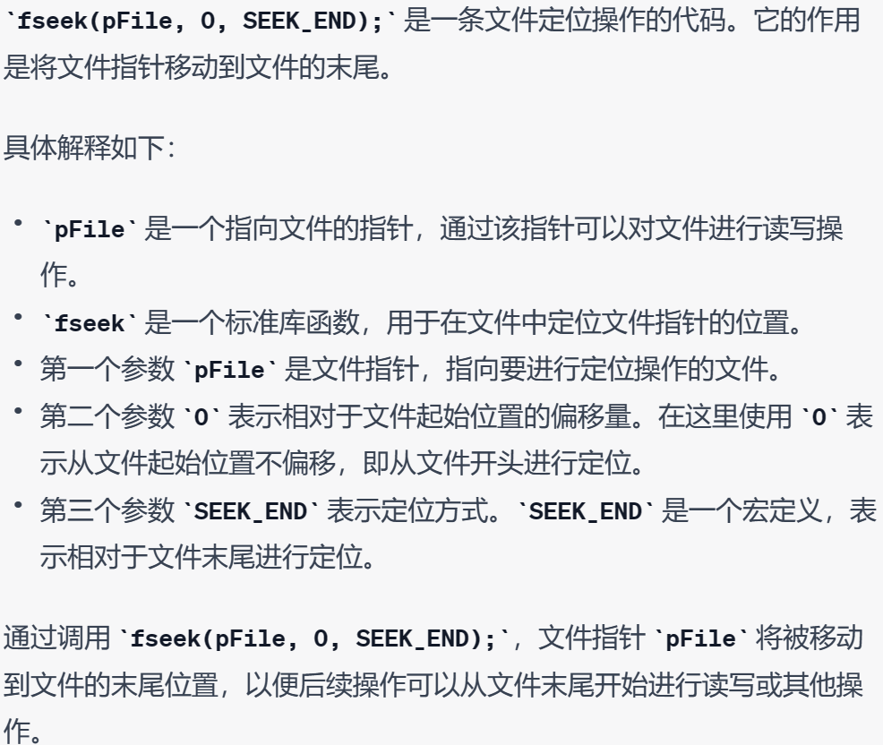
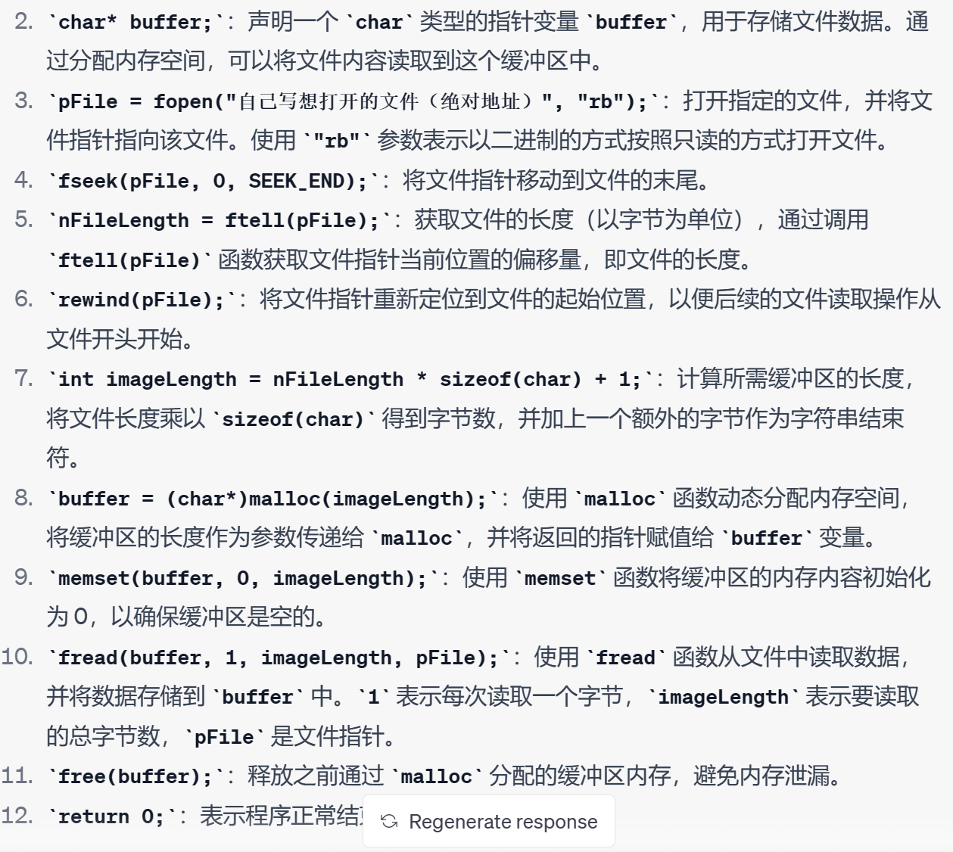

First stage of learning，i finish the online class about how to analyse the PE format,but the basic part of learning PE format i have never studied.
So in the second stage of learning ,i will learn to use load PE and 010Editor for the in-depth understanding of PE format!besides ,i will also learn from the blogs.
It is necessary for me to write a blog about the studying of PE format.

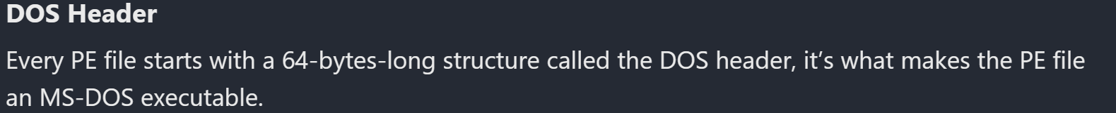
我怎么记得这个DOS Header是用来告诉电脑，当这个文件在MS-DOS操作系统上跑的时候大部分情况是不能运行
